Rapid User Group Meeting
June 28, 2013
Chicago, IL

Almost sixty people attended this year’s Rapid user group meeting. While enjoying a Mexican buffet dinner, users had the opportunity to visit with one another and to hear updates on several Rapid projects and about new, upcoming enhancements.
Below are the meeting’s agenda and notes.

Welcome and Announcements
Tom Moothart, Assistant Dean of Resource Delivery Services, at Colorado State University, welcomed guests and made several announcements.
- Rapid continues to grow, and since our last user group meeting in June of 2012, twenty-six new sites have joined the system. One of those sites, the University of Wollongong, is Rapid’s first Australian member. A list of the other twenty-five sites follows.

- The newest Rapid pod is the VALE (Virtual Academic Library Environment) group of libraries. Based in New Jersey, the VALE pod currently has seven members.

CRL project and review
Jane Smith, Coordinator of RapidILL, gave a brief update on the CRL/LHL project which began on July 1, 2012.
- In the past year, 131 CRL members who do not belong to Rapid have been set up and trained to use Rapid for making requests from CRL/LHL. These libraries are limited to the LHL4CRL and CRL holdings. To date two of these libraries have decided to become full Rapid participants and we anticipate a number more from this project.
- In addition to adding additional Rapid participants, the LHL4CRL project has, by necessity, added an enhancement to the Rapid system. This enhancement is a New Request page which allows libraries who do not use OCLC or any other online resource sharing system to enter requests directly into Rapid manually.

Rapid Rocks
Several members have asked about our Rapid Rocks newsletter. Rapid Rocks was on hiatus during the yearlong CRL project and will begin again on July 1st. Each Rapid Rocks issue is sent to all of the Rapid lists and is posted on the Rapid website (click the “Rapid Rocks” link near the top of the left-hand toolbar). If you have ideas for a Rapid Rocks issue or would be interested in guest authoring an issue, please contact Jane at: jane.smith@colostate.edu

Book Chapter Update
Tom Delaney, the Director of Rapid Outreach and Support, updated the attendees on Rapid’s book chapter feature. Released on July 1st, 2012, there are currently 40 participants using book chapters. The most recent edition of Rapid Rocks is a duplication of the handout that Tom referred to in his presentation.
If you have questions about participating in the book chapter option or would like information about holdings for book chapters, please contact Tom at: tgdelaney@rapidill.org

Medical Pod Update
Tom continued by bringing everyone up-to-date on Rapid’s Medical Pod. There are already eighteen libraries in the Medical pod and there has been a good bit of interest from other sites as well. Watch for an upcoming Rapid Rocks issue which will detail the requirements and pricing for Medical pod participation.

Easy Lending
As of June 28th, at the time of the user group meeting, Rapid’s open access database topped 7 million open access articles! Every Rapid site participates in Easy Lending and there is no charge for this feature. Articles are supplied from our Open Access database with no human intervention and the turnaround time for Easy Lending articles averages 1-2 minutes. In your borrowing statistics, you can identify Easy Lending requests by supplier “Open”.

Rapid Technical Updates
Greg Eslick, Director of Rapid Technology, continued the meeting with several updates from the Rapid’s Tech team. Though the names of the Tech team members are probably unfamiliar to most of you, the work they do is vital to Rapid’s smooth operation and continuing improvements.
- Fail-over Server: in the past year Rapid has established a new fail-over server. This server is located in Kansas which removes it from weather events or extended power outages that might affect the Rapid hardware in Colorado. The fail-over server is a vital part of Rapid’s continuing performance in the case of extenuating circumstances.
Let’s hope we never have to use it.
- Time Zone Localization: this enhancement was developed by request of many Rapid users. Because the Rapid servers are located at Colorado State University in Fort Collins, CO, all of the timestamps on requests and other Rapid actions were in Mountain Time. This can be confusing and subtracting or adding hours to follow the requests in your own time zone could become frustrating. Rapid sites can now set their own time zone. To set your own time zone in the Rapid system:

- Click the My Profile link in the Tools area on Rapid’s left-hand toolbar.
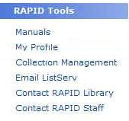

- Use the “Timezone” drop down box in the Edit Site Profile area to select the appropriate time zone.
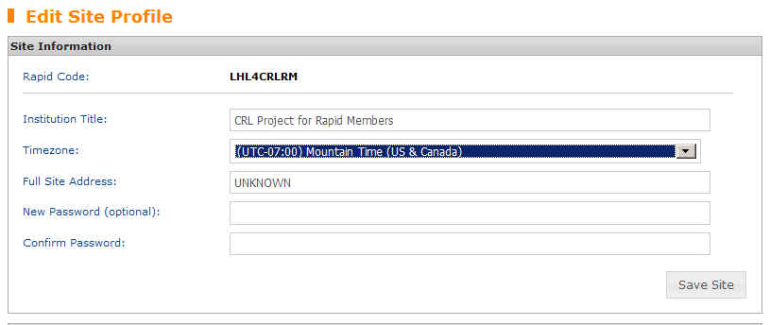

- Remember to click Save Site.

- Geo-location: Sometimes the tech team will add a feature just for fun and that is the case with Rapid’s new geo-location. We have added each site’s state/country to a map. If you’d like to see the reach of the Rapid system, you can check out this enhancement by clicking the Member Map link near the top of the left-hand toolbar.

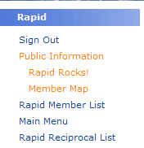

Greg concluded by mentioning that there is a lot of technical work that goes on behind the scenes and the sole purpose of the Tech team is to enhance member’s use of the system.

New Features and Enhancements
Mike Richins, the Coordinator of Customer Service continued the Rapid User Group meeting by announcing and describing two new features and one enhancement to the system. The new features are:

Unmediated Borrowing for Rapid Client Users
Libraries that use the Rapid Client to send their requests into Rapid from OCLC WorldCat Resource Sharing will soon have a new and exciting process available to use. The Unmediated Borrowing process will automatically query your new article and book chapter requests in WorldCat Resource Sharing or WorldShare and send them into Rapid. This will reduce staff time spent manually querying the Rapid system. And since this will replace the Rapid Client, you will no longer need to use and maintain a separate piece of software. We are currently testing the Unmediated Borrowing process and it should be available to any Rapid Client user within the next couple of months. More information will be posted to the Rapid listservs when this is available. If you have any questions, please contact the Rapid team at Rapidstaff@rapidill.org
ILLiad Addon
Rapid has developed an ILLiad addon designed to supplement your Rapid workflow within ILLiad. Depending on where the request is in your workflow the addon will do one of two things:
- If the ILLiad transaction contains a Rapid number in the ILL Transaction Number field, the addon will automatically pull up the Rapid Status Check page for that request with the ILLiad client interface;
- If the ILLiad transaction is not a Rapid request, the addon will launch our new “New Request” page and automatically populate the fields in a new request form. You can then submit the request into Rapid by a simple click of a button.

The addon will be available as a download from the Rapid webpage. We plan to add additional functionality to the ILLiad addon and suggestions/ideas are welcome.
Watch for an upcoming Rapid Rocks issue that will describe this addon fully.

Thanks to Melissa Brown at the University of Minnesota Libraries for suggesting this feature and for assisting in its development and testing

RapidX4ALL
Rapid is proud to present our newest enhancement. RapidX4ALL. RapidX4ALL allows Rapid libraries to upload NON-Rapid requests to be processed by the powerful RapidX delivery service. RapidX4ALL functionality will be accessible through the new RapidX page, which is currently in beta release and will be made available to all Rapid libraries sometime in the next couple of months. (If you are interested in trying RapidX4ALL ahead of the general release, please contact the Rapid staff (rapidstaff@rapidill.org))

Features of RapidX4ALL include:
- Lenders can upload PDF, TIF or HTML file types
- The ability to send via Odyssey and Ariel
- A dynamic address book specific to your Rapid login that lets you store, edit and access delivery methods and addresses for libraries that request from you.
- Adding a cover sheet to your file that includes your library’s OCLC symbol and institution name, document ID number and copyright notice.
- Documents automatically deleted from the Rapid server two weeks after the file is uploaded.

When RapidX4ALL is released to everyone, there will be messages and instructions sent to the Rapid listservs and it will be a featured issue of Rapid Rocks.

A list of the 25 new Rapid libraries since July 2012 is below.

WELCOME NEW RAPID LIBRARIES!
(New members added since July 1, 2012)

AUTOW University of Wollongong, Australia
BMC Bryn Mawr College
CCH California State University, Chico
CFS California State University, Fresno
CHU Humboldt State University
CLO California State University, Long Beach
CSO Sonoma State University
CTU California State University, Stanislaus
EIB Edinboro University
EMU Emory University
EXG Grand Valley State University
EZT Michigan Technological University
IRU New Mexico State University
ISM Southern Methodist University
JBE Olivet Nazarene University
JFU Loyola University Chicago, Health Sciences Library
KSW Wichita State University
LYU Lehigh University
NJP William Paterson University of New Jersey
NJS Richard Stockton College of New Jersey
NRU Norwich University
STH Seton Hall University
UBF University of New Brunswick
UPM Pennsylvania State University
XFF Western Washington University
YJT Medaille College

